Mentone Horse Riders Club Inc.

Committee Induction
Version 1.0
November 21, 2016
Created by:
Victoria Wilcox

Welcome to the MHRC committee!
This document has been put together to make your transition into a committee role easier. The information contained will provide guidelines for the positions and management of the club.

Information included in this document
Statement of Purpose
Policies and Procedures – Incorporations Act and HRCAV Constitution
Position descriptions
Committee contact details
Resource skills within the club
Previous year’s annual, financial, fundraising and membership reports

MHRC Statement of Purpose
Mentone Horse Riders Club was founded as a social riding club by a close-knit group of parents whose children rode together at Mentone Pony Club (formerly at Pillars Road, Bangholme). The club has maintained a friendly, supportive feel and membership has usually been limited to around 35 people to achieve this. Rallies are focused around a shared lunch hour which promotes relationships within the club. Members volunteer their time and resources for the benefit of all.

MHRC Policies and Procedures
The committee must refer to two documents to guide processes and make decisions.
Because MHRC is an incorporated club, we follow the rules set out by the Incorporations Act. This can be found on the Consumer Affairs Victoria website under ‘Clubs and not-for-profits’ ‘Running an incorporated association’ (click for link) ‘Model rules’.
The club is also a member of the Horse Riding Club Association of Victoria (HRCAV) and refers to the HRCAV Constitution document to guide policies and procedures. This document is found on the HRCAV website under ‘Rules and Guidelines’ ‘HRCAV Manual’ (click for link) ‘Constitution of HRCAV’.
As a committee member it is your responsibility to understand the rules of the club therefore it is strongly advised you read over these documents as soon as possible. Decisions need not be made in haste; time can be taken to re-visit these documents to ensure the integrity of the club is being upheld.

Position Descriptions
Type | Position | Description
Governance Roles | President | Provides leadership and direction to the Committee to achieve the club’s agreed goals. Is responsible for ensuring the Committee fulfils its responsibilities for the governance and success of the club. Diplomatically manages the relationships both within and outside the club. Attends to rule, conduct or administration issues throughout the term of office bearing. Is the spokesperson for the club and the chair of all meetings. Calls for good interpersonal skills, leadership ability and pragmatism.
 | Vice President | Assists and supports the President. Performs duties as directed by the Committee. In the President’s absence, the Vice President may be required to carry out duties relating to the President’s role and may act as the chair for meetings. Calls for good interpersonal skills, leadership ability and pragmatism.
 | Secretary | The primary administration officer responsible for the documentation and communication of the activities of the club and its Committee. Provides communication between the Committee, members and outside agencies. Tasks include: receive and administrate memberships, prepare agendas, prepare and distribute minutes, receive and disseminate correspondence to and from the club. Calls for excellent organisational skills and efficiency.
 | Treasurer | Responsible for the financial supervision of the club. Tasks include: management and reconciliation of club bank account, preparation of annual budget, basic forecasting, monitoring revenue and expenditure and simple financial reporting. Book-keeping skills are valued in this position.
Governance and/or Organisational Roles | General Committee | Made up of non-executive committee members with additional ordinary members if required – no more than six (6). Responsible for assisting the office bearers to run the club by attending general committee meetings where they may communicate on behalf of other club members, vote on decisions and form sub-committees, should the club require.
Organisational Roles | Rally Coordinator | Organises venues and instructors for monthly rallies within club budget. Produces and sends rally information to members monthly. Receives RSVPs from members and arranges appropriate riding groups taking varying combinations, levels and requests into consideration. Calls for good organisational skills, forward planning and a love of cryptic puzzles.
 | Event Coordinator | Plans, organises and executes one or more events that fund the club’s activities for the year. Involves coordination of members and creation of sub-committees to achieve success. Calls for excellent organisational and interpersonal skills.
 | TTT Entry Coordinator | Responsible for in-club advertisement of TTT events, organising training days if applicable, putting together teams, collecting and sending entries.
 | Newsletter Editor | Produces and sends out the club’s monthly newsletter. Collects important information about upcoming events, competition results, committee communications, notification of meetings and other articles of interest to members. Requires basic computer skills.
 | Website Manager | Responsible for the continued improvement and maintenance of the club’s website. Keeps information current, advertises upcoming events, updates photos and results, and makes changes to content at Committee’s request. Requires basic computer skills.
 | Catering Manager | Coordinates lunch for members attending monthly rallies. Involves purchasing (on behalf of club), preparing and serving food on rally days, handling petty cash, set-up and pack-up of canteen. May elect a sub-committee to help with catering for events. This role requires a person with safe food handling experience or training.
 | Uniforms | The point of contact for purchase and ordering of uniforms for club members.
Information from the Incorporations Act regarding ‘Vacation of Office’:
56 Vacation of office
(1) A committee member may resign from the Committee by written notice addressed to the Committee.
(2) A person ceases to be a committee member if he or she—
(a) ceases to be a member of the Association; or
(b) fails to attend 3 consecutive committee meetings (other than special or urgent committee meetings) without leave of absence under rule 67; or
(c) otherwise ceases to be a committee member by operation of section 78 of the Act.

Committee Contact Details
Type | Position | Member Name | Phone | Email
Governance Roles | President | Tory Wilcox | 0422 063 866 | vlwilcox@hotmail.com
 | Vice President | Alex Greenhill | 0419 117 048 | alexandra.greenhill@gmail.com
 | Secretary | Jo Universita | 0409 011 057 | josephineuni@gmail.com
 | Treasurer | Vicki Ryan | 0439 340 743 | vicki@ryanryte.com.au
Organisational Roles/General Committee | Rally Coordinator | Tory Wilcox | 0422 063 866 | vlwilcox@hotmail.com
 | Fundraising Coordinator | Georgina Stubbs | 0407 451 361 | adele.g.events@gmail.com
 | TTT Entry Coordinator | Rhonda Noble | 0402 526 027 | rjnoble@optusnet.com
 | Newsletter Editor | Jo Universita | 0409 011 057 | josephineuni@gmail.com
 | Website Manager | Isobel Freeman | 0420 646 599 | issyfreeman17@hotmail.com
 | Canteen Manager | Debi Dunstan | 0418 179 571 | debidunstan@hotmail.com
 | Uniforms | Sharon Willrath | 0404 333 177 | swillrath@icloud.com
 | General Committee | Linda Hall | 0416 199 314 | thehalls@bigpond.com.au

Resource skills
Many members have valuable skills, knowledge and experience that may contribute to the success of the club. The list below is not exhaustive; please modify or add others as you see fit – this is for your own reference.
Member Name | Expertise
Benita McDonough | Qualified instructor and level assessor
Debi Dunstan | Club catering manager, food handling license, industry experience
Georgina Stubbs | Club event coordinator, industry event coordinator
Jillian Wilcox | Founding member, involved in committee for many years
Jo Universita | Club secretary and newsletter editor, web and graphic design experience
Michele Binder | Previously club fundraising and TTT coordinator
Rhonda Noble | Club TTT coordinator, founding member, previously club president and treasurer
Sally Woodward | Registered nurse, printing business
Sharon Willrath | Founding member, previously club secretary, rally coordinator and uniform organiser
Tory Wilcox | Club president and rally coordinator, previously newsletter editor and general committee
Tryphena Gahan | Show judge
Vicki Ryan | Club treasurer, industry administrative experience
Wendy Sangster | Registered nurse, previously club risk management officer

Previous Year’s Reports

2016 President’s Report
It is with a great sense of satisfaction and achievement that I give my President’s report this year.
Participation
Our club and its members have been extremely active in both competition and training with a noticeable increase in the number of members competing this year and a consistent average of 17 riders per rally, which is roughly 50% of our membership.
Membership
We have seen a 20% increase in membership from 2015, with 12 new members this year. During the year the committee re-visited the topic of capping our full membership at 30 riders in order to limit the increasing expenses of rallies and to retain our social, friendly values.
Fees
At the beginning of the year, the committee introduced the non-rally membership, which gave members the option to pay for rallies on a pay-as-you-go basis. This has proven to be a good decision as we have retained a few long-standing members who still wish to be part of the club without the full fees. We also reduced the membership fees for people wishing to join after July, in line with the HRCAV reduction in fees. At the last general meeting in August, the club membership fees were discussed and it was decided all our fees would remain the same, and a ten to fifteen dollar fee would be added to rally lessons starting in 2017.
Club status/grounds
Having been a happily roaming club for many years now, the novelty is wearing off due to the increase in costs for ground hire and the desire to put our energy and funds into something of our own. A number of members have been active in pursuing leads for more permanent grounds and they are currently in discussion with them about a possible solution for us. To those members, thank you for the time and energy you have taken to do this – it is a frustrating and time consuming exercise! If anyone is interested in being involved with our ‘find a home’ campaign please let me know.
Fundraising
Our fundraising effort this year was not as rewarding as last year, making just a third of the figure of our 2015 competition. This does happen from time to time, and we must not be disheartened! The incoming committee will be discussing our 2017 fundraiser in the coming weeks and a sub-committee will be formed to help with planning and organising. If you’d like to be part of the sub-committee, or if you have a bright idea about another fundraising activity, please get in touch with the incoming Event Coordinator (soon to be announced) to express your interest.
Committee
This year’s committee have shown great dedication to improving the club’s administration and organisation.
- A committee induction booklet has been created as a guide for all incoming committee members with information about the positions, contact details, rules, resources and information from the previous year to assist with planning.
- Our website has been given a fresh, new face and the user-friendly features make editing and updating a whole lot easier, allowing us to keep our members and others up-to-date.
- A public Facebook page was created to provide information to the rest of the world about the goings-on of Mentone HRC. This is particularly useful when it comes to our competition as many people from other clubs look here for information before going to our website. We can also show off our photos on here, so don’t forget to send yours in!
Thank you
Linda - In May this year, Linda resigned from her position as Vice President and I would like to take this opportunity to thank you for your contributions to the club and your time and dedication during this period.
Jess – As most of you know, Jess will not be re-joining Mentone next year. On behalf of the club, I’d like to thank you for all the effort, time and energy you gave to your committee positions over the past few years and wish you all the best in your future equestrian pursuits.
Debi and Adrian – another year you have spoiled us with your delicious and lovingly prepared meals and drinks. We are so lucky to have you, please never leave! If the club could afford it we’d send you to Hawaii, but please accept this wine as a sign of our thanks instead!
Members - Our club operates on the collective efforts of its members – thanks to all of you who have lent a hand, and ear, a shoulder in some cases (!) and contributed to making Mentone what it is. At the beginning of the year, I asked everyone to think about a riding goal they had for the year. Have a think back to this time last year – how much you were riding? Where was your horse was ‘at’ in its training? Where were you at in your training? I have seen some incredible personal achievements from so many of you this year, from overcoming a challenging horse to overcoming injury to get back in the saddle again. Take the time to recognise your achievements, no matter how small, because it’s easy to focus on where we want to be and not give ourselves credit for the little wins we have along the way.
Belle - Speaking of wins, we sure hit the jackpot when Belle walked into our lives at the start of the year! Coming from a long and revered career with the Victorian Mounted Police, it didn’t take long for Belle to be discovered by every club in the area and we are so fortunate to have won her loyalty to us. Belle, thank you for your commitment to our club, for your flexibility when rallies change direction, your willingness to share your knowledge, your patience and absolute regard for the animals we ride and for teaching us that there is a capable rider in all of us.
Benita - I would also like to thank Benita for her commitment to our club this past year. You have been so generous of your instruction, guidance and time this year and it is very much appreciated.
Jill - Thanks also to Jill for having us here today, and for allowing us to have a drink with our Christmas lunch!
Committee - Finally a very big thank you to the rest of the 2016 committee for the endless hours of work they have put in – Jo, Vicki, Tracy, Sharon and the general committee members – thank you.
As we head into the new HRCAV year, may the falls be light, your horses fair and the results of your riding be with you. Have a Merry Christmas!
Tory Wilcox

2016 Year in Review
Date | Item | Description
18 Oct 15 | AGM | @Serenity Lane
15 Nov 15 | Christmas Party | @Serenity Lane
07 Dec 15 | Exec Meet | @Linda Hall’s
17 Jan 16 | Rally | @Chelsea PC w/ Belle Bourke & Andy Rouget
31 Jan 16 | Exec Meet | @Tory Wilcox’s
01 Feb 16 | Gen Meet | @Serenity Lane
21 Feb 16 | Rally | @Chelsea PC w/ Belle Bourke & Benita McDonough
28 Feb 16 | Training Day | @Willow Lane w/ Sarah Schroder for TTT CT
01 Mar 16 | Exec Meet | @Vicki Ryan’s
20 Mar 16 | Rally | @Five Star w/ Belle Bourke – Sally Woodward fractured shoulder
17 Apr 16 | Rally | @Wilkira Park w/ Belle Bourke & Rhiannon Dunn
15 May 16 | Rally | @Chelsea PC w/ Belle Bourke
18 May 16 | Private Meet | @Kerry Paterson’s w/ Tory, Kerry, Sally & Kerry’s husband re: Kerry’s membership, insurance, safety
25 May 16 | Exec Meet | @The Sands Hotel
 | Committee Resignation | Linda Hall
19 Jun 16 | Rally | @Willow Lane w/ Belle Bourke & Courtney Fraser
 | Gen Meet | @Willow Lane RE: Fundraiser
03 Jul 16 | Club Fundraising Event | @WPNEC – Dressage Jackpot
17 Jul 16 | Rally | @Five Star w/ Belle Bourke & Benita McDonough
10 Aug 16 | Gen Meet | @Chelsea RSL
21 Aug 16 | Rally | @Five Star w/ Belle Bourke & Rhiannon Dunn
 | Succession Planning | Nomination information and forms handed out at rally and emailed this week
18 Sep 16 | Rally | @Oakwood w/ Belle Bourke & Shane Simpson
 | Succession Planning | Nominations received by end of rally day
16 Oct 16 | Competition Rally | @Peninsula CT & Dressage Day – 20 members competed
20 Nov 16 | Christmas Rally & AGM | @Serenity Lane – In-house competition: Show ring and games
21 Nov 16 | Hand-over Meeting | @The Riviera Hotel

2016 Secretary’s Report
Mentone has had a great year with growth in membership and somehow pulled off the dressage comp at the 11th hour. Thank you all those members that helped on the day especially the executive committee who were there from 6:30 am till 6:30pm - huge effort!
As most of you know I am stepping down from secretary and have also joined a new club as their secretary. So thank you for having me and I’ll see you all out and about. I will be more than happy to pass on my knowledge and experience please feel free to contact me!
Jess Lewis

2016 Treasurer’s Report
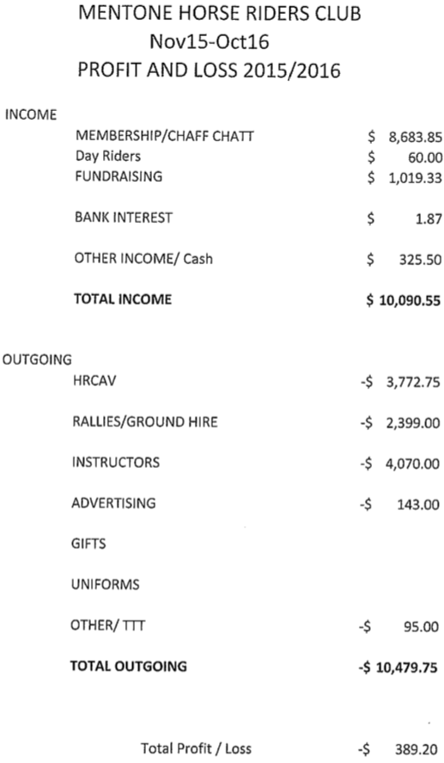

2016 Financial Report
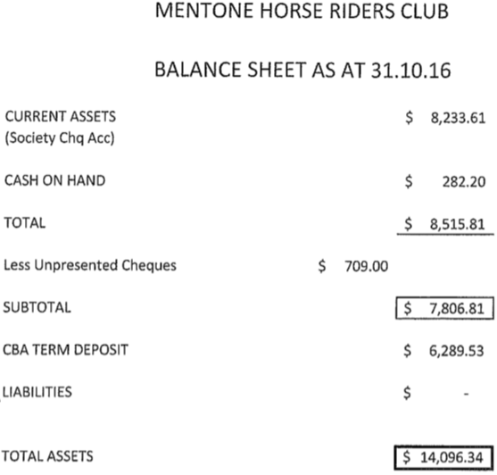

2016 Fundraising Report
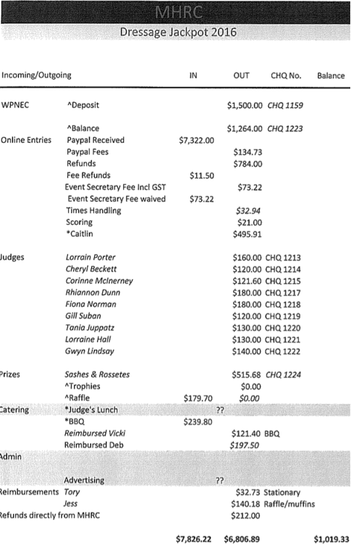

2016 AGM Minutes
November 21st 2016
Meeting open at 12:40pm
Attending: Tory, Jess, Georgie, Vicki, Paula, Tracy, Jo, Lee, Debbi, Jill, Linda, Rhonda, Genevieve, Isobel, Tara, Alex, Sharon, Sally, Adrian, Chris (Adrian’s brother), Brad, Gerard, Nicole, Wendy, Tracy Sangster, two friends of Jill.
Apologies Leah and Rochelle
Minutes from last meeting accepted
President’s report - see above
Secretary’s report – see above
Treasurer’s report – see above
Uncontested nominees declared elected to the following positions:
President Tory Wilcox
Secretary Jo Universita
Treasurer Vicki Ryan
Event Coordinator Georgina Stubbs
TTT Coordinator Rhonda Noble
Website Manager Isobel Freeman
Catering Manager Debi Dunstan
Newsletter Editor Jo Universita
Uniforms Sharon Wilrath
All members present took part in a secret ballot to decide the contested positions of Vice President and Rally Coordinator. Sharon retracted her nominations from both positions. The following members were elected:
Vice President Alex Greenhill
Rally Coordinator Tory (10 votes to Tory, 7 to Linda)
All non-exec committee members considered general committee and Linda was voted in as the tenth member of the general committee.
No other matters arising.
Meeting closed at 1pm.
End of document

